Preventing bullying in vocational education and work
- Personen met arbeidshandicap meer slachtoffer van pesten
In 2013 gaf 16,1% van de personen met een arbeidshandicap aan gepest te worden op het werk. Voor personen met erge hinder was dit 23,8%, voor personen met een beperkte hinder 15%. Deze aantallen liggen beduidend hoger dan bij werknemers zonder arbeidshandicap, zijnde 8,2%. De Commissie Diversiteit vraagt verder onderzoek naar de hoge cijfers van pestgedrag bij personen met een arbeidshandicap en dringt aan op maatregelen om dit gedrag te keren.
Grip vzw. (s.d.). Slechts vier op tien personen met een arbeidshandicap hebben werkbaar werk! Geraadpleegd op 12 april, via http://www.gripvzw.be/werk/1072-vier-op-tien-personen-met-een-arbeidshandicap-hebben-werkbaar-werk.html

- Vraag om redelijke aanpassingen en probleem met pesten op het werk van een werknemer met een handicap
Een werknemer met multiple sclerose die zich in een rolstoel verplaatst, nam contact op met het Centrum. Hij had zijn werkgever om aanpassingen gevraagd (toegang tot het gebouw, werkplek enz.) en werd omwille van zijn handicap op het werk gepest. Nadat hij naar aanleiding van een onderhoud met de directie een verslag had ontvangen waarin die haar bezorgdheid uitsprak over de verslechterde gezondheidstoestand van de werknemer en de gevolgen hiervan op het gebied van veiligheid en de uitvoering van zijn taken, nam de werknemer contact op met het Centrum omdat hij vreesde te zullen worden ontslagen. Het Centrum raadde hem aan om de directie een brief te sturen en daarin duidelijk te maken welke aanpassingen hij nodig had en om te vragen om een einde te maken aan de pesterijen. Het Centrum bezorgde de vakbond eveneens juridisch advies met het oog op een vergadering tussen de werknemer, zijn vakbondsafgevaardigde en de werkgever. Tijdens deze vergadering stemde de werkgever met de gevraagde aanpassingen in en beloofde hij om een einde te maken aan de pesterijen.
Grip vzw. (s.d.). Inhoud van Handicap News, de nieuwsbrief van het IGKR rond handicap. Geraadpleegd op 12 april 2017, via http://www.gripvzw.be/anti-discriminatie/1030-handicap-news-de-nieuwsbrief-van-het-igkr-rond-handicap.html

- Getuigenis Patrick: “Vandaag geef ik met trots les”
Patrick volgde buitengewoon onderwijs. Met de hulp van Job-Link is hij nu aan de slag als instructeur computer. Lees en bekijk zijn verhaal hier.
Ik studeerde af als tuinbouwer in het BUSO-onderwijs. Nadat ik zes maanden thuis had gezeten, kreeg ik een brief van GTB in de brievenbus met de vraag om langs te komen voor een gesprek. Zo’n brief werd naar iedereen gestuurd die afstudeerde uit het BUSO en na zes maanden nog werkloos was.
Tijdens het gesprek met GTB vroegen ze me wat ik al gedaan had, en welke richting ik uit wou. Ik vertelde over mijn schoolloopbaan. Op dat moment waren de computer en het internet serieus aan het opkomen, en ik had thuis toegang tot allebei. Ik bedacht dat een functie in deze richting mij enorm boeide en dat ik hiermee graag mijn brood zou verdienen.
De trajectbegeleiders van GTB zetten me eerst met de voeten op de grond, en gaven aan dat ik me zou moeten bijscholen als ik echter verder wilde richting computerwerk. Samen gingen we op zoek naar een opleidingscentrum en we vonden dit al snel.
Ik kwam terecht bij Job-Link en ging er een interne opleiding computer volgen. Vervolgens volgde ik een stage om te bekijken of ik wat ik tijdens de interne opleiding had geleerd, ook kon toepassen in een echte werksituatie. De laatste stap zou een vacaturegericht stage zijn. Maar ik ben nooit zo ver geraakt.
Na een zestal maanden interne opleiding in het opleidingscentrum, kreeg ik de vraag of ik daar als halftijds werknemer wilde starten om administratief werk te doen. Ik aarzelde geen seconde en ging met veel plezier in op het aanbod. Een jaar later kan ok voltijds aan de slag: als deeltijds administratief medewerker én deeltijds hulpinstructeur computer.
Intussen zijn we een aantal jaar verder. Sinds augustus 2010 ben ik geen hulpinstructeur meer, maar instructeur. Ik leer de mensen nu volledig zelf aan wat ik ooit zelf leerde bij Job-Link.
Patrick - instructeur computer
Patrick. (3 maart 2017). Getuigenis Patrick: “Vandaag geef ik met trots les”. Geraadpleegd op 17 april 2017, via http://unia.be/nl/publicaties-statistieken/publicaties/getuigenis-patrick

- Getuigenis Rebecca: “Ik liet mijn blindheid me niet tegenhouden”
Rebecca is assistente dierenarts en liet haar handicap nooit in de weg staan om haar dromen te verwezenlijken. Lees haar verhaal hier.
Met dieren werken: dat was wat ik wilde. Ik heb mijn handicap nooit in de weg laten staan om mijn dromen te verwezenlijken. Ik heb immers evenveel recht om te gaan en staan als iedereen. In Vlaanderen was er geen opleiding tot dierverzorging of paraveterinair. Maar in Nederland was deze opleiding er gelukkig wel! Ik heb er mijn diploma behaald en werk nu als assistent dierenarts. Ik doe mijn job supergraag!
Rebecca - assistent dierenarts

Rebecca. (3 maart 2017). Getuigenis Rebecca: “Ik liet mijn blindheid me niet tegenhouden”. Geraadpleegd op 17 april 2017, via http://unia.be/nl/publicaties-statistieken/publicaties/getuigenis-rebecca
- Getuigenis Eric: “Mezelf herpakken en bekijken wat ik wel nog kon”
Eric is zaakvoerder en had na zijn ongeval twee keuzes: klagen of zich herpakken. Het resulteerde in een bloeiende zaak voor auto-aanpassingen. Lees zijn verhaal hier.
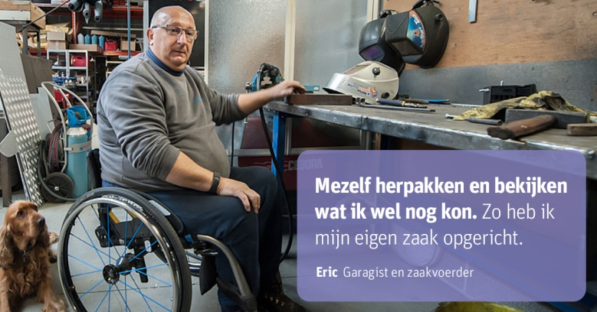
Na mijn ongeval in 1983 had ik twee keuzes. Ik kon triest blijven zitten en klagen over hoe het zou kunnen geweest zijn. Of ik kon me herpakken en bekijken wat ik wél nog kon, en dit zo zachtjesaan uitbreiden, met eenvoudige aanpassingen waardoor ik steeds meer en meer weer zélf kon doen. Het gevolg? Mijn werk was én is nog steeds mijn hobby. Ik heb mijn eigen zaak met succes opgericht, en ik stel er nu anderen in tewerk. Dankzij dit heb ik een volwaardig sociaal leven. Ik kan nu mensen verder helpen die in hetzelfde schuitje zitten als ikzelf nu bijna 35 jaar geleden. Dat schept voldoening. Het laat me elke ochtend als een gelukkig mens wakker worden, ondanks die rolstoel.
Eric – zaakvoerder

- Getuigenis Amal: “Mijn lessen gaan door in toegankelijke gebouwen en lokalen”
Amal is docente en waardeert het dat haar werkgever rekening houdt met haar beperkte mobiliteit, zonder dat ze dat hoeft te vragen. Lees haar verhaal hier.

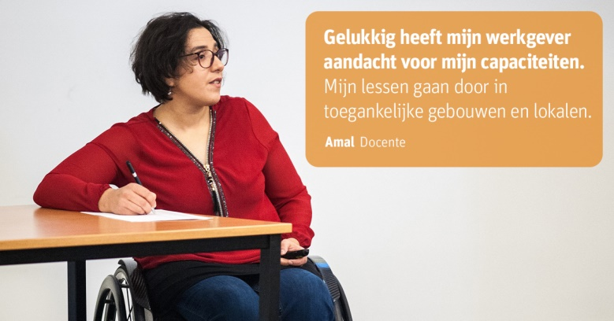
Dat mensen met een beperking ook kunnen werken, zou een evidentie moeten zijn. Maar niets is minder waar. Mensen met een beperking hebben het moeilijk op de arbeidsmarkt, door de onaangepaste infrastructuur en de vele vooroordelen over wat we niet kunnen. Gelukkig heeft mijn werkgever wel aandacht voor mijn capaciteiten. Ik werk als docente. Zonder dat ik het hoef te vragen, zorgt de personeelsdienst er bij de opstelling van de lessenroosters voor dat mijn lessen plaatsvinden in toegankelijke gebouwen en lokalen. Deze inspanning maakt het voor mij aangenaam werken.
Amal - docente
- Unia, jaarverslag 2015
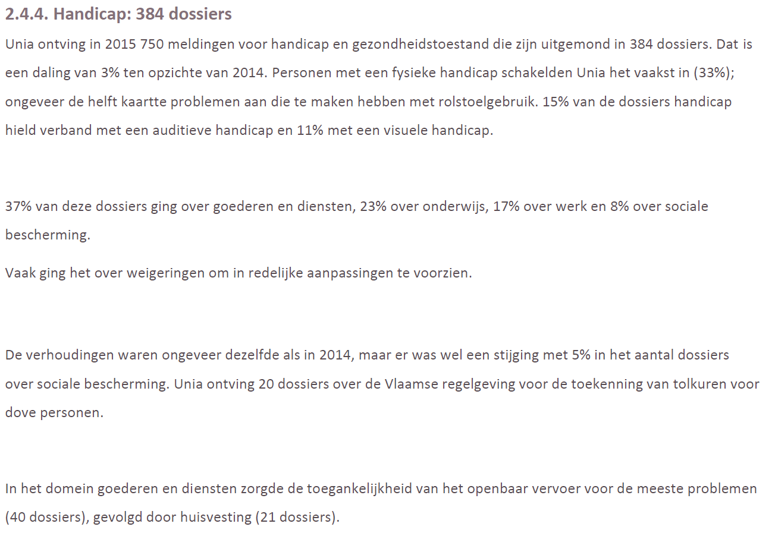
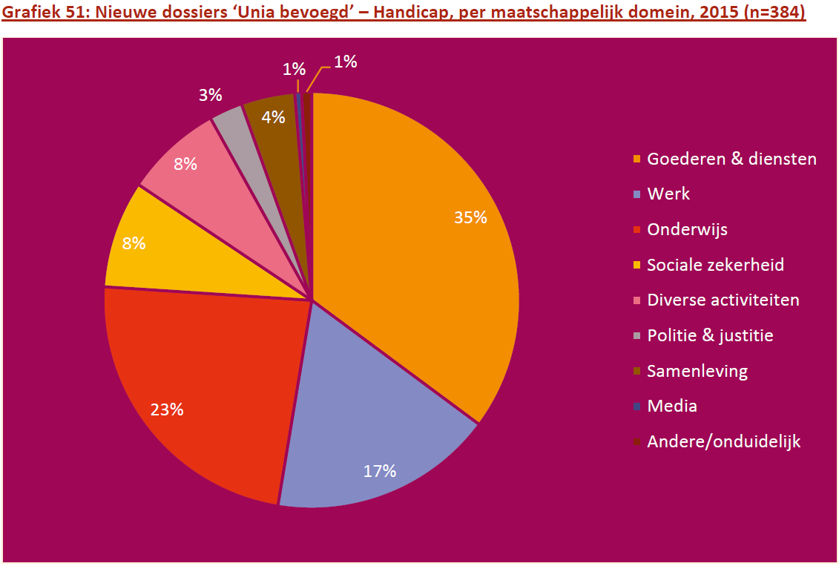
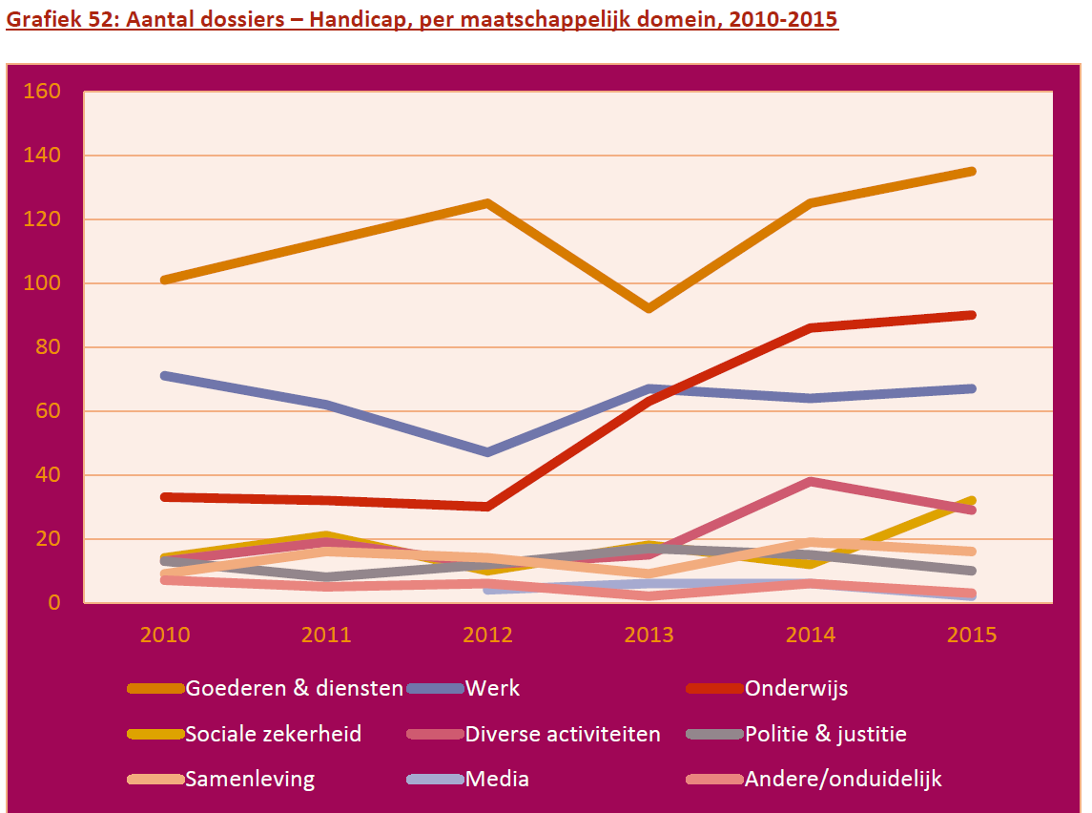
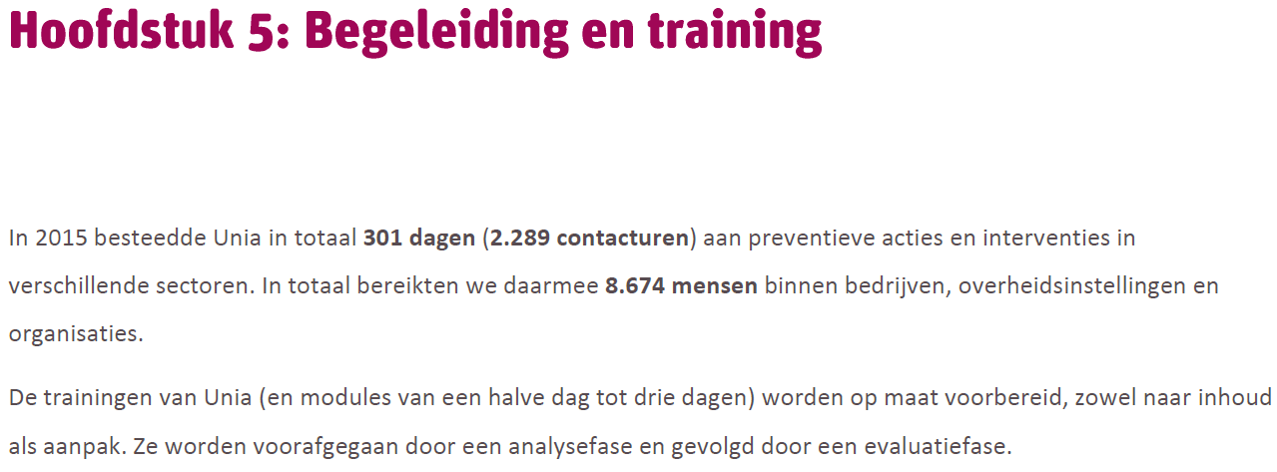
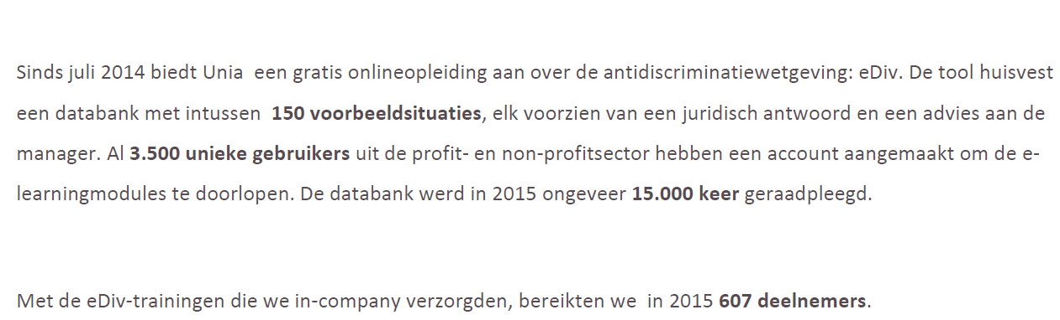
Unia. (2015). Cijferverslag_2015. Geraadpleegd op 17 april 2017, via http://unia.be/files/Documenten/Jaarrapport/Cijferverslag_2015.pdf

- Definition, types, characteristic, different contexts and prevention of bullying Wikipedia
Bullying is the use of force, threat, or coercion to abuse, intimidate, or aggressively dominate others. The behavior is often repeated and habitual. One essential prerequisite is the perception, by the bully or by others, of an imbalance of social or physical power, which distinguishes bullying from conflict.^{[1]} Behaviors used to assert such domination can include verbal harassment or threat, physical assault or coercion, and such acts may be directed repeatedly towards particular targets. Rationalizations of such behavior sometimes include differences of social class, race, religion, gender, sexual orientation, appearance, behavior, body language, personality, reputation, lineage, strength, size, or ability.^{[2][3]} If bullying is done by a group, it is called mobbing.^{[4]}
Bullying can be defined in many different ways. The United Kingdom of Great Britain and Northern Ireland has no legal definition of bullying,^{[5]} while some states in the United States have laws against it.^{[6]} Bullying is divided into four basic types of abuse – emotional (sometimes called relational), verbal, physical, and cyber.^{[7]} It typically involves subtle methods of coercion, such as intimidation.
Bullying ranges from one-on-one, individual bullying through to group bullying called mobbing, in which the bully may have one or more "lieutenants" who may seem to be willing to assist the primary bully in his or her bullying activities. Bullying in school and the workplace is also referred to as peer abuse.^{[8]} Robert W. Fuller has analyzed bullying in the context of rankism.
A bullying culture can develop in any context in which humans interact with each other. This includes school, family, the workplace,^{[9]} home, and neighborhoods. In a 2012 study of male adolescent American football players, "the strongest predictor [of bullying] was the perception of whether the most influential male in a player's life would approve of the bullying behavior".^{[10]}

Definition
There is no universal definition of bullying, however, it is widely agreed upon that bullying is a subcategory of aggressive behavior characterized by the following three minimum criteria: (1) hostile intent, (2) imbalance of power, and (3) repetition over a period of time.^{[11]} Bullying may thus be defined as the activity of repeated, aggressive behavior intended to hurt another individual, physically, mentally or emotionally.
The Norwegian researcher Dan Olweus^{[12]} says bullying occurs when a person is "exposed, repeatedly and over time, to negative actions on the part of one or more other persons". He says negative actions occur "when a person intentionally inflicts injury or discomfort upon another person, through physical contact, through words or in other ways."^{[12]} Individual bullying is usually characterized by a person behaving in a certain way to gain power over another person.^{[13]}

Types
Individual bullying can be classified into four types.^{[14]} Collective bullying is known as mobbing, and can include any of the individual types of bullying.
Physical, verbal, and relational bullying are most prevalent in primary school and could also begin much earlier whilst continuing into later stages in individuals lives. It is stated that Cyber-bullying is more common in secondary school than in primary school.^{[14]}

Individual
Individual bullying tactics can be perpetrated by a single person against a target or targets.^{[15]}

Physical
This is any bullying that hurts someone’s body or damages their possessions. Stealing, shoving, hitting, fighting, and destroying property all are types of physical bullying. Physical bullying is rarely the first form of bullying that a target will experience. Often bullying will begin in a different form and later progress to physical violence. In physical bullying the main weapon the bully uses is their body when attacking their target.Sometimes groups of young adults will target and alienate a peer because of some adolescent prejudice. This can quickly lead to a situation where they are being taunted, tortured, and beaten-up by their classmates. Physical bullying can lead to a tragic ending and therefore must be stopped quickly to prevent any further escalation.^{[16]}

Verbal
This is any bullying that is conducted by speaking. Calling names, spreading rumors, threatening somebody, and making fun of others are all forms of verbal bullying. Verbal bullying is one of the most common types of bullying. In verbal bullying the main weapon the bully uses is their voice. In many cases, verbal bullying is the province of girls. Girls are more subtle (and can be more devastating), in general, than boys. Girls use verbal bullying, as well as social exclusion techniques, to dominate and control other individuals and show their superiority and power. However, there are also many boys with subtlety enough to use verbal techniques for domination, and who are practiced in using words when they want to avoid the trouble that can come with physically bullying someone else.^{[17]}

Relational
This is any bullying that is done with the intent to hurt somebody’s reputation or social standing which can also link in with the techniques included in physical and verbal bullying. Relational Bullying is a form of bullying common amongst youth, but particularly upon girls. Relational bullying can be used as a tool by bullies to both improve their social standing and control others. Unlike physical bullying which is obvious, relational bullying is not overt and can continue for a long time without being noticed.^{[18]}

Cyber-bullying
Cyber bullying is the use of technology to harass, threaten, embarrass, or target another person. When an adult is involved, it may meet the definition of cyber-harassment or cyberstalking, a crime that can have legal consequences and involve jail time.^{[19]} This includes email, instant messaging, social networking sites (such as Facebook), text messages, and cell phones.

Collective
Collective bullying tactics are employed by more than one individual against a target or targets.

Mobbing
Main article: Mobbing
Mobbing refers to the bullying of an individual by a group, in any context, such as a family, peer group, school, workplace, neighborhood, community, or online. When it occurs as emotional abuse in the workplace, such as "ganging up" by co-workers, subordinates or superiors, to force someone out of the workplace through rumor, innuendo, intimidation, humiliation, discrediting, and isolation, it is also referred to as malicious, nonsexual, nonracial / racial, general harassment.^{[20]}

Characteristics

Of bullies and accomplices
Studies have shown that envy and resentment may be motives for bullying.^{[23]} Research on the self-esteem of bullies has produced equivocal results.^{[24][25]} While some bullies are arrogant and narcissistic,^{[26]}they can also use bullying as a tool to conceal shame or anxiety or to boost self-esteem: by demeaning others, the abuser feels empowered.^{[27]} Bullies may bully out of jealousy or because they themselves are bullied.^{[28]} Psychologist Roy Baumeister asserts that people who are prone to abusive behavior tend to have inflated but fragile egos. Because they think too highly of themselves, are frequently offended by the criticisms and lack of deference of other people, and react to this disrespect with violence and insults.^{[29][full citation needed]}
Researchers have identified other risk factors such as depression^{[30]} and personality disorders,^{[31]} as well as quickness to anger and use of force, addiction to aggressive behaviors, mistaking others' actions as hostile, concern with preserving self-image, and engaging in obsessive or rigid actions.^{[32]} A combination of these factors may also be causes of this behavior.^{[33]} In one study of youth, a combination of antisocial traits and depression was found to be the best predictor of youth violence, whereas video game violence and television violence exposure were not predictive of these behaviors.^{[34]}
Bullying may also result from a genetic predisposition or a brain abnormality in the bully.^{[35]} While parents can help a toddler develop emotional regulation and control to restrict aggressive behavior, some children fail to develop these skills due to insecure attachment with their families, ineffective discipline, and environmental factors such as a stressful home life and hostile siblings.^{[14]} Moreover, according to some researchers, bullies may be inclined toward negativity and perform poorly academically. Dr. Cook says that "a typical bully has trouble resolving problems with others and also has trouble academically. He or she usually has negative attitudes and beliefs about others, feels negatively toward himself/herself, comes from a family environment characterized by conflict and poor parenting, perceives school as negative and is negatively influenced by peers".^{[36]}
Contrarily, some researchers have suggested that some bullies are psychologically strongest and have high social standing among their peers, while their targets are emotionally distressed and socially marginalized.^{[37]} Peer groups often promote the bully's actions, and members of these peer groups also engage in behaviors, such as mocking, excluding, punching, and insulting one another as a source of entertainment.^{[14]} Other researchers also argued that a minority of the bullies, those who are not in-turn bullied, enjoy going to school, and are least likely to take days off sick.^{[38]}
Research indicates that adults who bully have authoritarian personalities, combined with a strong need to control or dominate.^{[39]} It has also been suggested that a prejudicial view of subordinates can be a particularly strong risk factor.^{[40]}

Of typical bystanders
Often, bullying takes place in the presence of a large group of relatively uninvolved bystanders. In many cases, it is the bully's ability to create the illusion that he or she has the support of the majority present that instills the fear of "speaking out" in protestation of the bullying activities being observed by the group. Unless the "bully mentality" is effectively challenged in any given group in its early stages, it often becomes an accepted, or supported, norm within the group.^{[41][42]}
Unless action is taken, a "culture of bullying" is often perpetuated within a group for months, years, or longer.^{[43]}
Bystanders who have been able to establish their own "friendship group" or "support group" have been found to be far more likely to opt to speak out against bullying behavior than those who have not.^{[44][45]}
In addition to communication of clear expectations that bystanders should intervene and increasing individual self-efficacy, there is growing research that suggests interventions should build on the foundation that bullying is morally wrong.^{[46]}
Among adults, being a bystander to workplace bullying was linked to depression, particularly in women.^{[47]}

Of victims
Dr. Cook says that "A typical victim is likely to be aggressive, lack social skills, think negative thoughts, experience difficulties in solving social problems, come from a negative family, school and community environments and be noticeably rejected and isolated by peers".^{[36]} Victims often have characteristics such as being physically weak, as well as being easily distraught emotionally. They may also have physical characteristics that make them easier targets for bullies such as being overweight or having some type of physical deformity. Boys are more likely to be victims of physical bullying while girls are more likely to be bullied indirectly.^{[48]}
The results of a meta-analysis conducted by Cook and published by the American Psychological Association in 2010 concluded the main risk factors for children and adolescents being bullied, and also for becoming bullies, are the lack of social problem-solving skills.^{[36]}
Children who are bullied often show physical or emotional signs, such as: being afraid to attend school, complaining of headaches or a loss of appetite, a lack of interest in school activities and spending time with friends or family, and having an overall sense of sadness.

Effects
Mona O'Moore of the Anti-Bullying Centre at Trinity College in Dublin, has written, "There is a growing body of research which indicates that individuals, whether child or adult, who are persistently subjected to abusive behavior are at risk of stress related illness which can sometimes lead to suicide".^{[49]} Those who have been the targets of bullying can suffer from long term emotional and behavioral problems. Bullying can cause loneliness, depression, anxiety, lead to low self-esteem and increased susceptibility to illness.^{[50]} Bullying has also been shown to cause maladjustment in young children, and targets of bullying who were also bullies themselves exhibit even greater social difficulties.^{[51]}

Suicide
Main articles: Bullying and suicide and List of suicides which have been attributed to bullying
Even though there is evidence that bullying increases the risk of suicide, bullying alone does not cause suicide. Depression is one of the main reasons why kids who are bullied commit suicide.^{[52]} It is estimated that between 15 and 25 children commit suicide every year in the UK alone because they are being bullied.^{[53]} Certain attributes of a person are correlated to a higher risk for suicide than others such as: American Indians, Alaskan Natives, Asian Americans, lesbians, gays, bisexuals and transgenders. When someone is unsupported by his or her family or friends, it can make the situation much worse for the victim.^{[54]}
While some people find it very easy to ignore a bully, others may find it very difficult and reach a breaking point. There have been cases of apparent bullying suicides that have been reported closely by the media. These include the deaths of Ryan Halligen, Phoebe Prince, Dawn-Marie Wesley, Kelly Yeomans, Jessica Haffer,^{[55]} Hamed Nastoh,^{[56]} April Himes,^{[57]} Cherice Moralez^{[58]} and Rebecca Ann Sedwick.^{[59]} According to the suicide awareness voices for education, suicide is, among 15 to 24 years olds, one of the leading causes of death for youth. Over 16 per cent of students seriously consider suicide, 13 per cent create a plan, and 8 per cent have made a serious attempt.^{[60]}

Violence
Serial killers were frequently bullied through direct and indirect methods as children or adolescents. Henry Lee Lucas, a serial killer and diagnosed psychopath, said the ridicule and rejection he suffered as a child caused him to hate everyone which he believes to have evoked this behavior. Kenneth Bianchi, a serial killer and member of the Hillside Stranglers, was teased as a child because he urinated in his pants and suffered twitching, and as a teenager was ignored by his peers.^{[61]} It is realised from these recent studies that individuals who were previously involved in a violent childhood whom was effected mentally and emotionally due these experiences later rationally adapts this violent behaviour and provokes other victims. This violent behavior that is performed by these so-called serial killers allows these individuals to escape from their past of feeling trapped and weak to taking control over innocent victim.

Positive development
Some have argued that bullying can teach life lessons and instill strength. Helene Guldberg, a child development academic, sparked controversy when she argued that being a target of bullying can teach a child "how to manage disputes and boost their ability to interact with others", and that teachers should not intervene, but leave children to respond to the bullying themselves.^{[62]}
The teaching of such anti-bullying coping skills to "would-be-targets" and to others has been found to be an effective long term means of reducing bullying incidence rates and a valuable skill-set for individuals.^{[63]}

Emotional intelligence
Main article: Bullying and emotional intelligence
Bullying is abusive social interaction between peers which can include aggression, harassment, and violence. Bullying is typically repetitive and enacted by those who are in a position of power over the victim. A growing body of research illustrates a significant relationship between bullying and emotional intelligence (EI). Mayer et al., (2008) defines the dimensions of overall EI as: "accurately perceiving emotion, using emotions to facilitate thought, understanding emotion, and managing emotion".^{[67]} The concept combines emotional and intellectual processes.^{[68]} Lower emotional intelligence appears to be related to involvement in bullying, as the bully and/or the victim of bullying. EI seems to play an important role in both bullying behavior and victimization in bullying; given that EI is illustrated to be malleable, EI education could greatly improve bullying prevention and intervention initiatives.^{[69]}

In different contexts

Disability bullying
Main article: Disability bullying
It has been noted that disabled people are disproportionately affected by bullying and abuse, and such activity has been cited as a hate crime.^{[72]} The bullying is not limited to those who are visibly disabled, such as wheelchair-users or physically deformed such as those with a cleft lip, but also those with learning disabilities, such as autism^{[73][74]} and developmental coordination disorder.^{[75][76]}
There is an additional problem that those with learning disabilities are often not as able to explain things to other people, so are more likely to be disbelieved or ignored if they do complain.^{[citation needed]}

Workplace bullying
Main article: Workplace bullying
Workplace bullying occurs when an employee experiences a persistent pattern of mistreatment from others in the workplace that causes harm.^{[88]} Workplace bullying can include such tactics as verbal, nonverbal, psychological, physical abuse and humiliation. This type of workplace aggression is particularly difficult because, unlike the typical forms of school bullying, workplace bullies often operate within the established rules and policies of their organization and their society. Bullying in the workplace is in the majority of cases reported as having been perpetrated by someone in authority over the target. However, bullies can also be peers, and occasionally can be subordinates.^{[89]}
Research has also investigated the impact of the larger organizational context on bullying as well as the group-level processes that impact on the incidence, and maintenance of bullying behavior.^{[90]} Bullying can be covert or overt. It may be missed by superiors or known by many throughout the organization. Negative effects are not limited to the targeted individuals, and may lead to a decline in employee morale and a change in organizational culture.^{[9]} A Cochrane Collaboration systematic review has found very low quality evidence to suggest that organizational and individual interventions may prevent bullying behaviors in the workplace.^{[91]}

In academia
Main article: Bullying in academia
Bullying in academia is workplace bullying of scholars and staff in academia, especially places of higher education such as colleges and universities. It is believed^{[by whom?]} to be common, although has not received as much attention from researchers as bullying in some other contexts.^{[92]}

In blue collar jobs
Bullying has been identified^{[by whom?]} as prominent in blue collar jobs, including on oil rigs and in mechanic shops and machine shops. It is thought that intimidation and fear of retribution cause decreased incident reports. In industry sectors dominated by males, typically of little education, where disclosure of incidents are seen as effeminate, reporting in the socioeconomic and cultural milieu of such industries would likely lead to a vicious circle. This is often used^{[by whom?]} in combination with manipulation and coercion of facts to gain favour among higher-ranking administrators.^{[93]}

In information technology
Main article: Bullying in information technology
A culture of bullying is common in information technology (IT), leading to high sickness rates, low morale, poor productivity, and high staff-turnover.^{[94]} Deadline-driven project work and stressed-out managers take their toll on IT workers.^{[95]}

In the legal profession
Main article: Bullying in the legal profession
Bullying in the legal profession is believed to be more common than in some other professions. It is believed that its adversarial, hierarchical tradition contributes towards this.^{[96]} Women, trainees and solicitors who have been qualified for five years or less are more impacted, as are ethnic minority lawyers and lesbian, gay and bisexual lawyers.^{[97]}

In medicine
Main article: Bullying in medicine
Bullying in the medical profession is common,^{[citation needed]} particularly of student or trainee doctors and of nurses. It is thought^{[by whom?]} that this is at least in part an outcome of conservative traditional hierarchical structures and teaching methods in the medical profession, which may result in a bullying cycle.

In nursing
Main article: Bullying in nursing
Even though The American Nurses Association believes that all nursing personnel have the right to work in safe, non-abusive environments, bullying has been identified as being particularly prevalent^{[quantify]} in the nursing profession although the reasons are not clear. It is thought^{[by whom?]} that relational aggression (psychological aspects of bullying such as gossipping and intimidation) are relevant. Relational aggression has been studied among girls but not so much among adult women.^{[95][98]}

In teaching
Main article: Bullying in teaching
School teachers are commonly the subject of bullying but they are also sometimes the originators of bullying within a school environment.

In other areas
As the verb to bully is defined as simply "forcing one's way aggressively or by intimidation", the term may generally apply to any life experience where one is motivated primarily by intimidation instead of by more positive goals, such as mutually shared interests and benefits. As such, any figure of authority or power who may use intimidation as a primary means of motivating others, such as a neighborhood "protection racket don", a national dictator, a childhood ring-leader, a terrorist, a terrorist organization, or even a ruthless business CEO, could rightfully be referred to as a bully. According to psychologist Pauline Rennie-Peyton, we each face the possibility of being bullied in any phase of our lives.^{[99]}
The author Ben Shapiro claims that liberals employ bullying to intimidate and silence their conservative opponents in an ongoing culture war.^{[100]}

Prevention
Bullying prevention is the collective effort to prevent, reduce, and stop bullying.^{[101]} Many campaigns and events are designated to bullying prevention throughout the world. Bullying prevention campaigns and events include: Anti-Bullying Day, Anti-Bullying Week, International Day of Pink, International STAND UP to Bullying Day, and National Bullying Prevention Month. Anti-Bullying laws in the U.S. have also been enacted in 23 of its 50 states, making bullying in schools illegal.^{[102]}
Wikipedia. (16 april 2017). Bullying. Geraadpleegd op 17 april 2017 via https://en.wikipedia.org/wiki/Bullying

- Masterproef ivm pesten
Bij het beschrijven van pestgedrag maakt men een onderscheid tussen twee vormen van pesten: direct en indirect pesten. Vormen van direct pesten zijn bijvoorbeeld plagen, dreigen, slaan, uitschelden,… Het verschil met indirect pesten is dat dit minder direct zichtbaar is. Hierbij worden kinderen bijvoorbeeld sociaal geïsoleerd doordat ze uitgesloten worden door de leeftijdsgenoten (Olweus, 1993).
Binnen pestgedrag kunnen 4 rollen onderscheiden worden: pesters, slachtoffers, pesterslachtoffers en niet-betrokken leerlingen. [...] De pesters zijn vaak weinig populair bij de klasgenoten, maar zijn wel sterk aanwezig en maken deel uit van de sociale netwerken in de klas (Veenstra et al., 2005). De 2de categorie zijn de slachtoffers. In tegenstelling tot de pesters worden ze gekenmerkt door hun fysieke zwakte, ze zijn anders dan de anderen (bijvoorbeeld doordat ze een andere etniciteit hebben, dikker zijn,…) en zijn niet assertief of agressief (Hoover, Oliver, & Thompson, 1993). Slachtoffers hebben meer kans op depressie en hebben bovendien een lagere eigenwaarde (Schuster, 1996), ze zijn vaak niet populair in de klas en hebben weinig vrienden (Salmivelli et al., 1996). Pesters kiezen hun slachtoffers niet willekeurig: ze kiezen vaak de personen die reeds voordien slachtoffer waren aangezien zij een makkelijk doelwit zijn (Olweus, 1978). Een relatief nieuw fenomeen in het onderzoek naar pesters is dat men een 3de categorie creëert naast pesters en slachtoffers, namelijk de pester-slachtoffers (Veenstra et al., 2005). Men spreekt over pester-slachtoffers wanneer iemand zowel slachtoffer is van pesten maar tegelijkertijd ook zelf anderen pest (Juvonen et al., 2003). Onderzoek geeft aan dat deze 3de groep een apart profiel heeft (Bowers, Smith and Binney, 1994) en dat deze groep meer problematisch gedrag vertoont in vergelijking met individuen die enkel pesten of enkel slachtoffer zijn (Ragatz et al., 2011). Deze groep wordt ook wel de “agressieve slachtoffers” genoemd (Hannish & Guerra, 2004). De pester-slachtoffers zijn niet populair en worden verworpen door de klas, waardoor ze agressief reageren op die klasgenoten (Veenstra et al., 2005). De 4de groep zijn de niet-betrokkenen of neutralen, zij zijn niet betrokken bij pesten. Dit vormt de grootste groep en zij zijn het meest populair in de klas (Veenstra et al., 2005).
Pesten is een aanhoudend probleem waar iedereen wel eens mee te maken krijgt. In een van de grootste studies over pesten onderzocht Olweus (1991) 150 000 studenten in Noorwegen, tussen 8 en 16 jaar. Uit de resultaten bleek dat meer dan 15% van de studenten betrokken was bij pesten. Ongeveer 9% hiervan rapporteerde zichzelf als slachtoffer en 2% was zowel pester als slachtoffer. Ook in Vlaanderen werd in 2006 reeds onderzoek gedaan naar de prevalentie van pestgedrag op school (Vandebosch et al., 2006). Dit was een grootschalig onderzoek naar cyberpesten waarbij ook klassiek pestgedrag aan bod kwam. Uit het onderzoek bleek dat 56,7% van de ondervraagden in de afgelopen 3 maanden slachtoffer was van pesten. 49,3% van de respondenten gaf toe weleens zelf te pesten en 78,6% van de ondervraagden was getuige van pesten. Er is een duidelijk verschil in pesten wat betreft geslacht. Jongens zullen eerder direct pesten en meer geweld gebruiken, meisjes zijn meer geneigd om indirecte strategieën toe te passen zoals uitsluiten en roddelen (Ahmad & Smith, 1994; Crick & Grotpeter, 1995; Schuster, 1996). Jongens zijn over het algemeen vaker betrokken bij pesten dan meisjes, zowel als pester en als slachtoffer (Schuster, 1996). Deze conclusie hangt mogelijk samen met het feit dat meisjes op een andere manier pesten die minder direct zichtbaar is en minder makkelijk wordt toegegeven in zelf-rapportering (Schuster, 1996). Wat betreft de leeftijd is er minder consistentie. In sommige onderzoeken vindt men dat het pesten afneemt bij ouder worden (Boulton & Underwood,1992; Olweus, 1991), in ander onderzoek vindt men geen effect van leeftijd (Hoover, Oliver & Hazier, 1992; Olweus, 1978). Eenzelfde onduidelijkheid over het verband vindt men bij de relatie tussen SES en pesten (Whitney & Smith, 1993, Sourander et al.,2000). Andere indicatoren die een rol spelen bij pesten zijn onderwijsprestaties en etniciteit. [...]
Pesten kan heel wat negatieve gevolgen hebben. Uit onderzoek blijkt dat pesten een invloed heeft op de psychologische gezondheid. Rigby (2003) onderscheidt hierbij 4 soorten gevolgen namelijk een laag welzijn en zelfbeeld, gevoelens van afkeer ten opzicht van een sociale omgeving (e.g. school of werkplek), psychologische kwelling zoals angst en depressie en psychosomatische klachten. Ook andere onderzoeken vinden hetzelfde verband tussen pesten en mentale gezondheid (Arseneault et al., 2010). Naast dit soort van gevolgen werd in ander onderzoek aangetoond dat pesten op school kan leiden tot agressie en falen op academisch vlak (Esbensen & Carson, 2009; Felix, Furlong, & Austin, 2009;Finkelhor, 2008). [...]
Maes, M. (2013-2014). ‘WE DON’T NEED NO EDUCATION...' Schoolmoeheid bij adolescenten en het verband met pester-status. Een multilevel-benadering. Geraadpleegd op 17 april 2017, via http://lib.ugent.be/fulltxt/RUG01/002/167/335/RUG01-002167335_2014_0001_AC.pdf

- Definition of Bullying, Unesco

Definition of bullying
"A person is bullied when he or she is exposed, repeatedly and over time, to negative actions on the part of one or more other persons, and he or she has difficulty defending himself or herself." (Dan Olweus)
Dan Olweus, creator of the Olweus Bullying Prevention Program, provides this commonly accepted definition for bullying in his book, Bullying at School: What We Know and What We Can Do (1993).
This definition includes three important components:
1. Bullying is aggressive behavior that involves unwanted, negative actions.
2. Bullying involves a pattern of behavior repeated over time.
3. Bullying involves an imbalance of power or strength.
- Workplace bullying
David is 16 years old with a severe learning disability who has been working at a local grocery store for four months. In the beginning he really enjoyed his job; but recently things at work have been getting tough. David was assigned a new supervisor a few weeks ago. That supervisor has been teasing David, and making it difficult for him to get his assigned duties done on time. A friend who works with David has told him that the supervisor is talking negatively about him to other co-workers. David has noticed that the supervisor goes out of his way to assign David the least desirable jobs in the store. David has developed anxiety about going into work and often feels physically ill after his shift. His previous supervisor gave him excellent marks on his initial performance review, but the current supervisor seems more invested in finding things David is doing wrong. David feels he is good at his job and wants to remain loyal to the store that hired him, but feels the current supervisor is treating him unfairly.

NCWD/Youth. (2015). Bullying and Disability Harassment in the Workplace: What Youth Should Know. Geraadpleegd op 17 april 2017, via http://www.ncwd-youth.info/information-brief-29

- Bullying and Disability Harassment in the Workplace: What Youth Should Know
- http://www.ncwd-youth.info/information-brief-29

- Algemene principes
- http://www.werk.belgie.be/defaultTab.aspx?id=23570

- VDAB raadt dove doctor beschutte werkplaats aan
- http://www.standaard.be/cnt/dmf20170419_02841434

- World report on disability
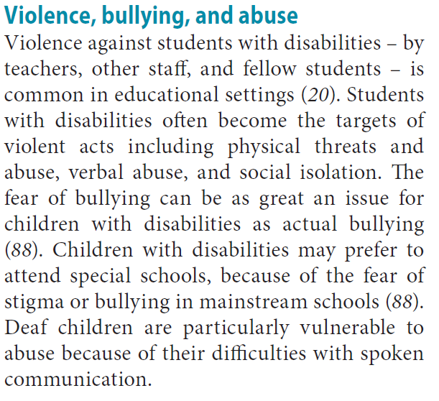
http://www.who.int/disabilities/world_report/2011/report.pdf
- How three young disabled people dealt with bullies
Research shows disabled children are much more likely to be bullied. Three young people who were once victimised tell their stories and share tips on tackling the problem.
This year's Anti Bullying Week has been asking schools to give particular attention to children with disabilities or special educational needs. The organisation behind the campaign, the Anti-Bullying Alliance (ABA), has published new research on attitudes to disablist language this week and cites other recent research which shows eight out of 10 children with learning disabilities have been bullied, and that disabled children at primary school are 50% more likely to be victimised.
Rebecca, Maxine and Ammaar were at the receiving end of bullying. They explain how they got through it in the hope that their stories will help those having trouble now.

'Speak up'
More than 90% of parents of children with Asperger Syndrome told the ABA that their child had been bullied in the past 12 months. Rebecca Parkin is 17 and has the condition. She was bullied regularly from the age of six until recently, when becoming a campaigning voice for others in her situation boosted her confidence. Rebecca says she was an "easy victim" for bullies. "I rarely spoke to anyone. I was really shy and kept to myself, even saying hello to someone was really difficult for me," she says.
You need to speak up so things will change
The problems began in primary school, where she was called names and excluded from friendship groups, but she describes high school as "a living hell". "I was called fat, crazy, weird, stupid, ugly. When I was about 12 a gang of 16-year-olds came up to me in a park and tried setting my hair on fire. In school I got hit and tripped up, I had food and water thrown on me. One day a boy cornered me and said he was going to find me after school and kill me. I also got abuse online and someone set up a fake account on YouTube in my name so people could leave nasty comments on my videos."
Rebecca was so badly affected that she began self-harming and needed help from mental health services. Things only changed for the teenager when she managed to speak up about what was happening to her. She says that she bugged teachers "until they did something about it" and that helping others in the same situation taught her that "you need to speak up so things will change".
"I know it's hard but if you can't vocalise what's wrong, write it down or draw it," says Rebecca. "Do whatever you can to show how you are feeling and what is going on."
Rebecca is now an anti-bullying campaigner with Ambitious about Autism, NSPCC and Ditch The Label.

'Take precautions'
Maxine Young is 22 and acquired a learning disability as the result of a brain tumour at the age of three.
If I do get bullied now, I say to them, why are you doing this?
"He called me brain tumour kid," says Maxine Young, referring to one boy who bullied her. She was consistently called names and teased about her size and appearance throughout primary and secondary schools, and then at college. Telling teachers led to bullies getting temporary exclusions from school, but the bullying only stopped completely when Maxine was physically assaulted at a bus station, and went to the police. The attacker got a two-year suspended sentence and was ordered to pay compensation. This, coupled with how seriously the police took her situation, has helped her grow in confidence. Maxine has now developed strategies to avoid being targeted in the future.
"If I do get bullied now, I say to them, why are you doing this? What's the point in bullying people when you won't get anything from it? I carry a personal alarm with me in case I do get assaulted again," says Maxine, who has also received self-defence coaching from the police.
Maxine now helps Mencap to give anti-bullying training to parents and carers of people with learning disabilities .
Mencap are keen to stress that Maxine's story is an exception to the rule. The charity says that in the last two years there were 124,000 disability hate crimes, but only 3% of these were recorded by the police, and only 1% resulted in prosecutions.

'Don't believe them'
Ammaar Hussein is 16 and has been a victim of bullying in the past because of his deafness. He recently made a video for the National Deaf Children's Society(NDCS) giving tips for ways to tackle bullies. One tip he offers is, "Don't believe the bullies".
I kept thinking 'do I really look so different?'
They would "speak very slowly, stretching their mouth and making fun of me" says Ammaar. It reached the stage where the bullies' words affected how he went about his daily life. "I kept thinking that I couldn't communicate properly and that people wouldn't understand me if I tried. I felt embarrassed.
"One boy called me a robot because I was wearing my hearing aids," he continues. "I felt really annoyed and ignored him but I kept thinking 'Do I really look so different?'"
He says his biggest mistake was to listen to what bullies told him. "I did not realise that they were trying to ruin my confidence," he says. "Remember, bullying is never your fault." Ammaar is now an anti-bullying ambassador at his school and he helps other deaf young people who are being targeted because they can't hear.

- Disablist Bullying
- https://nobullying.com/disablist-bullying/

- Bullying Children with Disabilities: A Parent’s Story
- https://www.navigatelifetexas.org/en/blog/article/bullying-children-with-disabilities-a-parents-story

- Bullying Disabled People Is Never Ok - But It’s Even Worse When You’ve Got 8.7 Million Fans Watching
- http://www.huffingtonpost.co.uk/lisa-egan/george-takei-facebook_b_5660280.html
- https://www.facebook.com/georgehtakei/photos/a.223098324386295.105971.205344452828349/1015489658480487/?type=1

- Mencap
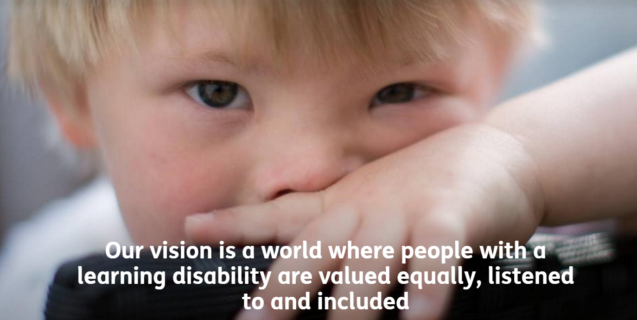
- https://www.mencap.org.uk/

- Resources for employers
- https://www.mencap.org.uk/learning-disability-explained/resources-employers

- Cyberbullying and SEN/disability
- https://www.anti-bullyingalliance.org.uk/tools-information/all-about-bullying/cyberbullying-0/cyberbullying-and-sendisability

- Anti-bullying allaince
- https://www.anti-bullyingalliance.org.uk/

